Ideation Phase
Define the Problem Statements

Date | 13 Feb 2026
Team ID | LTVIP2026TMIDS84622
Project Name | FlightFinder – Navigating Your Air Travel Options
Maximum Marks | 2 Marks

Customer Problem Statement Template:
Customers, especially students and working professionals, often struggle to search and book flights conveniently due to busy schedules, complex booking procedures, and scattered flight information across multiple platforms. Existing flight booking systems can be confusing, time-consuming, and sometimes lack transparency in pricing, availability, and booking details. These issues lead to frustration, uncertainty, and reduced user satisfaction.
There is a need for a unified, user-friendly flight booking platform that simplifies the process of searching, comparing, and booking flights. The system should provide real-time flight availability, clear pricing details, secure user authentication, and smooth booking management. Such a platform should ensure convenience, reliability, and a seamless experience for travelers while also supporting operators and administrators in managing flight data efficiently.
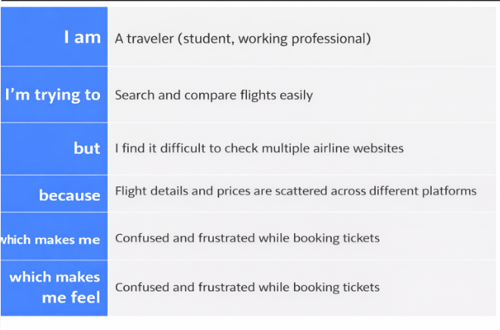
Example:

Problem Statement (PS) | I am (Customer) | I’m trying to | But | Because | Which makes me feel
PS-1 | A traveler (student / working professional) | Search and compare flights easily | I find it difficult to check multiple airline websites | Flight details, prices, and availability are scattered across different platforms | Confused and frustrated while booking tickets
PS-2 | A frequent traveler | Book affordable flights quickly | I do not get clear real-time availability and simple booking options | Many flight booking systems are complicated and time-consuming | Stressed and uncertain about travel plans

